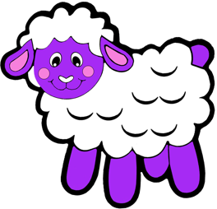
Little Lambs
St Mary’s Church 201 High Road Loughton
Essex IG10 1BB
Tel: 07769 433023
E-mail: littlelambs@stmarysloughton.com

REGISTRATION/WAITING LIST FORM
I would like to enroll my child at Little Lambs. I am enclosing a non-returnable deposit of £45 by bank transfer £45 to HSBC, Sort Code: 40-30-25, Account No: 51450069. No deposit required for children eligible for FEEE2. I understand this is the cost of the registration and starter pack*. On receipt of your completed registration form and deposit you will receive confirmation of your application by email and your child’s name will go on the waiting list.
*starter pack includes: polo shirt, sweatshirt and plimsolls.

PERSONAL DETAILS
Child’s Full Name Sex (Boy/Girl)

Date of Birth Home Tel No. Home Email

Address

Mother’s name Mobile/Work Tel No

Father’s name Mobile/Work Tel No

ATTENDANCE REQUIREMENTS
Sessions available are mornings 9:15 am to 12:15 pm and afternoons are 12:15 pm to 2:45 pm.

How many sessions do you require in total per week (minimum 4 up to 10 sessions)? ____
Please CIRCLE below your first and second choice (4 sessions minimum)

FIRST CHOICE SECOND CHOICE

Monday morning/afternoon Monday morning/afternoon Tuesday morning/afternoon Tuesday morning/afternoon Wednesday morning/afternoon Wednesday morning/afternoon Thursday morning/afternoon Thursday morning/afternoon Friday morning/afternoon Friday morning/afternoon
Start Date Required (please CIRCLE): Sept 2024/ Sept 2025/Sept 2026 Anticipated leaving date

Does your child attend any other setting, if so, which one?

Do you currently attend a place of worship and, if so, which one?

SIGNATURE
Where a child has more than one Parent/Guardian/Carer both must sign.
I/We have read and agree to the fees, terms and conditions enclosed and certify that all information given in this form is correct. I/We will inform Little Lambs Ltd in writing should any of the details on the Registration Form change.

Signed Date Signed Date

